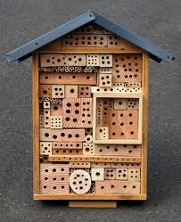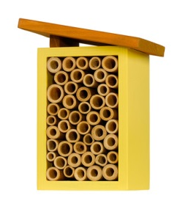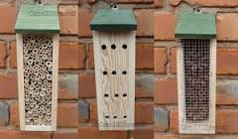
Promoting Native Pollinators!
(Re-printed in part from US Forest Service)
The act of “pollination” occurs when pollen grains are moved between two flowers of the same species by wind or animals. Successful pollination results in the production of healthy fruit and fertile seeds, allowing plants to reproduce. Without pollinator visits to tomatoes and other fruit and vegetable plants in our gardens, we would have no produce! Almost 90% of all flowering plants rely on animal pollinators for fertilization, and about 200,000 species of animals act as pollinators. Of those, 1,000 are hummingbirds, bats, and small mammals such as mice. The rest are insects like beetles, bees, ants, wasps, butterflies and moths. Most of these are native species. Note: The honey bee was an introduction to this continent in the 1620’s.
Worldwide, approximately 1,000 plants grown for food, beverages, fibers, spices, and medicines need to be pollinated by animals in order to produce the goods on which we depend. Foods and beverages produced with the help of pollinators include but are not limited to: apples, bananas, blueberries, chocolate, coffee, melons, peaches, potatoes, pumpkins, vanilla, almonds, and tequila. (Imagine a world without some of these things!) Even pasture fed cattle need pollinators to produce alfalfa hay fields. In the United States, pollination by honeybees and other insects produces $40 billion worth of products annually!
How can we help?
- Provide Food: Plant flowering plants, trees and shrubs that will be in bloom in succession, providing nectar and pollen throughout the summer season.
- Provide Water: Using shallow pans or bird baths with rock platforms for easy access. Keep them clean!
- Provide Shelter: Many plants will provide shelter but man-made bee hotels can be interesting to observe and bring many of our native pollinators closer to your garden. (see photo)

Visit the following websites for information on building bee hotels, and promoting native pollinators into your garden.
http://www.foxleas.com/bee_house.htm
http://www.opalexplorenature.org/Beehotels#/0
http://oardc.osu.edu/ALE
http://pollinator.org/PDFs/OhioBeeGuideFINAL.pdf
www.pollinator.org

